
Name Class Date
A molecule of a substance always contains the same number of atoms of each element joined together in the molecule.
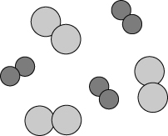 | Hydrogen and oxygen gas can be mixed together in any proportion.  When the gases react they always form a compound with two atoms of hydrogen and one atom of oxygen in each molecule. | 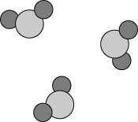
The chemical formula for water is written as H₂O.
The number 2 tells us that two hydrogen atoms are joined to one oxygen atom in each molecule.
- Colour the atoms of different elements using different colours.
By counting up the atoms, write the chemical formula beside each of the molecules.
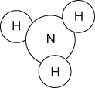  ammonia | 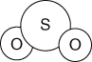  sulfur dioxide | 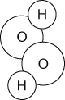  hydrogen peroxide
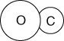  carbon monoxide | 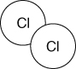  chlorine | 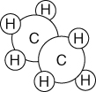  ethane
- Draw a diagram of a methane molecule, formula CH₄.
- Some compounds are not made up of molecules, but have billions of atoms joined together.  The formulae of these compounds tells us the ratio of atoms of each element joined together.  The structure of atoms in iron sulfide is shown opposite.  - What do you think the formula of iron sulfide would be? | 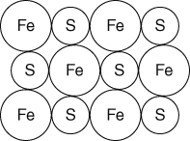
b Explain your answer to question 3a.

I can...
- identify elements, mixtures and compounds from particle diagrams
- describe what a chemical formula tells you about a substance.

