
Name Class Date
When iron and sulfur are mixed and heated, as shown opposite, they form iron sulfide.  - Choose one of the words below to complete this sentence.  When the reaction starts you see the mixture ...  smoking glowing evaporating freezing | 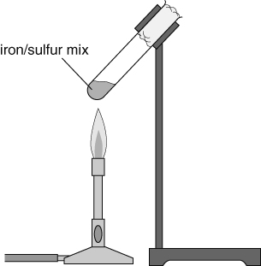
- The diagrams below represent the atoms in this reaction.
Complete the labels on the diagrams and colour in the diagrams, making the sulfur atoms yellow and the iron atoms grey.
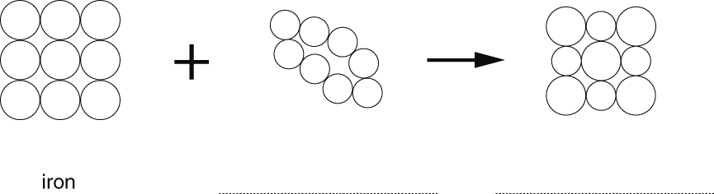
- Complete the table showing the names of elements in a compound.
Element 1 | Element 2 | Name of compound
magnesium | sulfur
 | chlorine | sodium chloride
 |  | lead oxide
I can...
- describe the changes you might see when compounds are formed
- name simple compounds.

