Name Class Date
- Describe four properties of metals that are important for the use illustrated opposite. (The first one has been completed for you.)  - Flexible: can be bent into different shapes. | 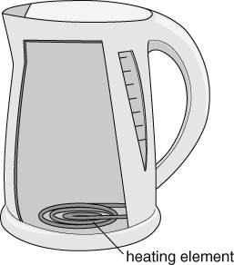  Heating element in a kettle.
- Describe three properties of non-metal elements that are usually
different from most metals. (Again, the first one has been completed for you.)
- Brittle: will crumble under pressure.

- Name the property that makes each of the following suitable for the use described.
a Steel, used for the sides of a radiator.
b Silver, used to make bangles and bracelets.
c Gold, used to make connections in computer circuits.
- Sometimes the properties of a substance makes it unsuitable for a particular use.
Complete the following sentences.
- Gold is not used to make water pipes because
- The handles of irons are not made of copper because
- Electrical connections are not made of silicon because
- Where are most metals found in the periodic table?

- State if the element described is likely to be a metal or a non-metal.
a A brown solid which bends easily into different shapes.
b A green gas with a strong smell.
c A silver solid (at room temperature) that melts just below body temperature and conducts
electricity.
I can...
- describe and identify metals and non-metals by their properties
- relate the use of an element to its properties
- classify elements as metals and non-metals.

