Name Class Date
- Complete the following list of properties of metals and non-metals.
(Some first letters have been included.)
Metals are: | Non-metals are:
melting point solids.  F – bend without breaking.  S when polished.  Good conductors of h .  conductors of electricity. | melting point solids, liquids and gases.  (when solid). They don’t bend easily and snap.  D looking solids.  conductors of heat.  Poor conductors of e .
- Choose a word/phrase from the box to describe the property shown by the picture.
brittle conductor of heat conductor of electricity flexible hard
high boiling point low melting point strong shiny

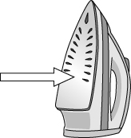 | 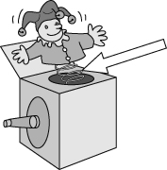
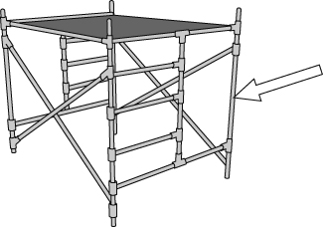 | 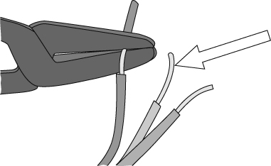
I can...
- describe and identify metal and non-metal elements by their properties
- relate the use of an element to its properties.

