Name Class Date
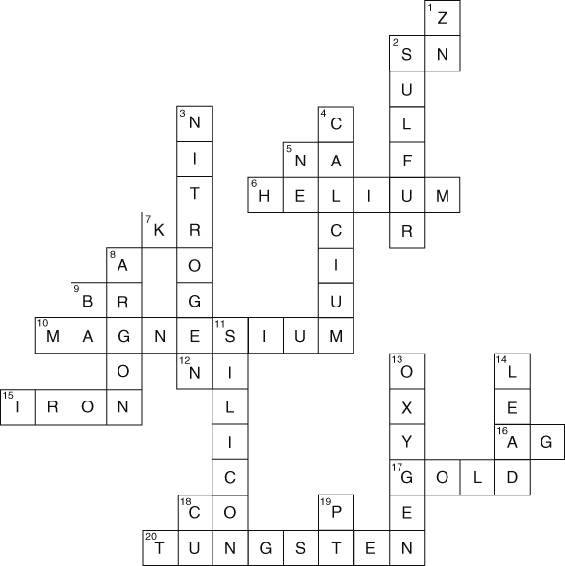
Write clues for the answers in the crossword.
ACROSS  2  5  6  7  9  10  12  15  16  17  18  20 | DOWN  1  2  3  4  5  8  9  11  13  14  18  19
I can...
- recognise some symbols for common elements
- use the periodic table to look up symbols for elements.

