Name Class Date
- Tick the box to show whether each of these sentences is true or false.
 | True | False
All matter is made up of atoms. |  | 
Elements can be split up into simpler substances. |  | 
There are millions of elements. |  | 
Each element is made of the same kind of atoms. |  | 
- Find out the symbols for the following elements
a aluminium b oxygen
c iron d calcium
- Draw lines to match up the element’s description to their symbols.
The most common element in the Earth’s crust C
A metal element known about for thousands of years N
The most common element in air O
The element in diamonds Au
- Choose one of the properties in the box below to match the use shown in the diagram.
heavy hard flexible soft
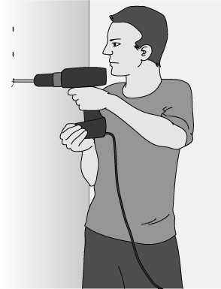
I can...
- explain what atoms and elements are
- find the chemical symbols for some elements
- describe some uses of elements related to their properties.

