
Name Class Date
- In the diagrams below, colour in the atoms of different elements, using different colours.
- For each diagram choose one of the following terms that best describes the model shown.
element compound mixture
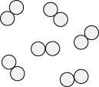 | 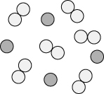
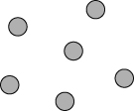 | 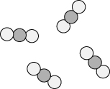
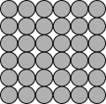 | 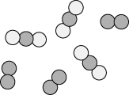
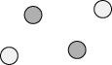 | 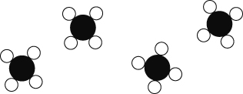
I can...
- identify elements, mixtures and compounds from descriptions and particle diagrams.

