Name Class Date
- Complete the concept map below to classify different types of matter.
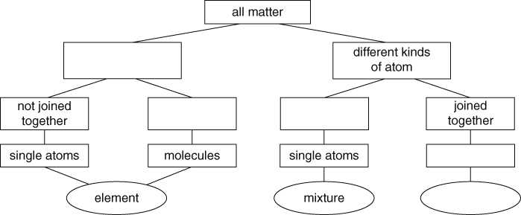
- Draw a diagram of each of the molecules described in the boxes below. You will need some way of showing the difference between atoms of the different types of elements.
- Water molecules contain one oxygen atom joined to two hydrogen atoms, which form an angle of 105° between them. | - Boron trifluoride molecules contain one boron atom joined to three fluorine atoms. The three fluorine atoms are equally spaced out with angles of 120° between them.
- Carbon dioxide molecules contain one carbon atom joined to two oxygen atoms in a straight line. | - Methane molecules contain one carbon atom joined to four hydrogen atoms. The hydrogen atoms are equally spaced out with angles of 109° between them.
I can...
- classify matter as elements or compounds containing atoms or molecules
- identify elements, mixtures and compounds from descriptions and particle diagrams.

