Name Class Date
The air is a mixture made up of different elements and compounds. The main gases in air are given in the table below, along with the amount of each found in 100 cm³ of dry air. Dry air has no water vapour in it.
Name of gas | Approximate volume of each gas in 100 cm³ of air
oxygen | 21
nitrogen | 78
argon | 0.95%
carbon dioxide | 0.05%
- Use the information in the table to draw:
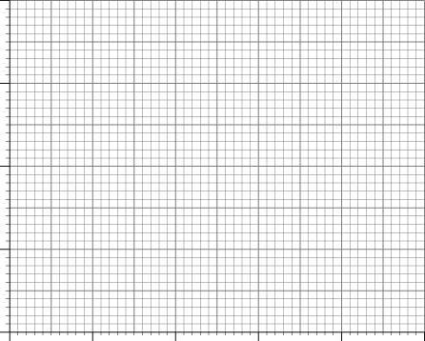  - a bar chart | 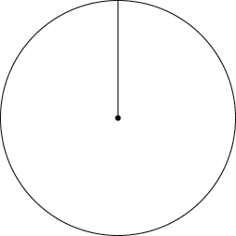  - a pie chart.

- Why is it so difficult to show the amount of carbon dioxide in the air on your graph?

- Which is the most abundant gas in air?
- Which gas makes up about one-fifth of the air?
- Look at the diagram below.
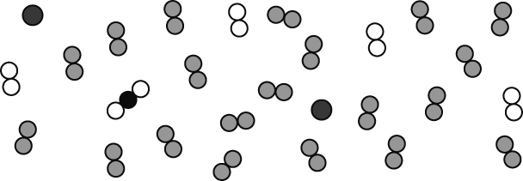
- Label the diagram to show examples of atoms, molecules, elements and compounds.
- Why is air considered to be a ‘mixture’?
I can...
- present data in pie charts and bar charts
- obtain information from tables and charts.

