Name Class Date
Aim
To find out if the volume of available air affects the time a candle will burn under a beaker.
Introduction
Candles use the oxygen in air when they burn and will go out when the oxygen is used up.
Prediction
- What do you think will happen?
Method
Apparatus  - tea light/candle  - different sized beakers: 200 cm³, 300 cm³, 400 cm³, 500 cm³  - heat-resistant mat  - stop clock  - lighter |  |  Take care to keep flammable materials away from flames.  Wear eye protection.
- Place a tea light/candle on a heat-resistant mat.  - Light the candle and immediately, but carefully,  place a beaker over it.  - Time how long it takes for the candle to go out.  - Record the volume of the beaker and the time  for flame to go out.  - Repeat steps A to D, changing the size of the  beaker used. | 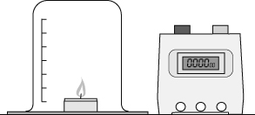
Recording your results
Record your results in the table below.
Volume of beaker (cm³) | Time to go out (s)

Considering your results/conclusions
- Complete the scatter graph for your results.  - If possible draw a line of best fit on your graph. | 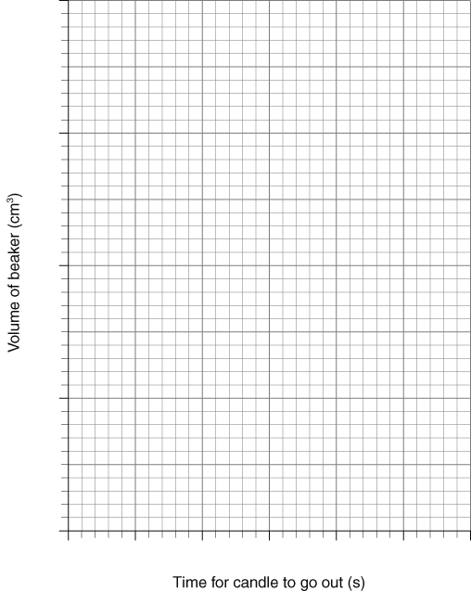
- What relationship, if any, is shown by your results and graph?

- Do your results support your hypothesis and prediction?

Evaluation
- What could you do to improve the investigation to be more sure of your conclusions?
- The method and experimental set up?

- The number of experiments you carried out?

I can...
- make a prediction using scientific ideas and test the prediction by experiment
- follow a given method and evaluate experimental procedures
- present data in scatter graphs, identify any relationships and draw a line of best fit.

