Name Class Date
- For each of the following particle diagrams say if they represent:
- a pure element
- a mixture of elements
- a pure compound
- a mixture of compounds
- a mixture of elements and compounds
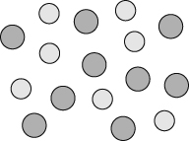 | 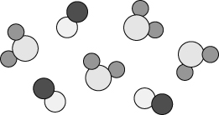
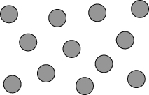 | 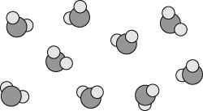
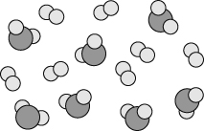 | 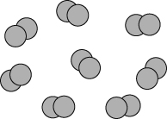
- Tick one of the boxes in each row to say what the substance is like.
Substance | Description | Element | Compound | Mixture
Air | Is made of atoms and molecules of different substances, which are not joined together. |  |  | 
Argon | Is made of atoms that are not joined to one another. |  |  | 
Carbon dioxide | Is made of molecules, each with two oxygen atoms and one carbon atom. |  |  | 
Oxygen | Is made of molecules, each with two oxygen atoms. |  |  | 
I can...
- recognise the difference between atoms and molecules
- identify elements, mixtures and compounds from descriptions and particle diagrams.

