
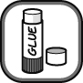
Name Class Date
Cut out the drawings of atoms and molecules at the bottom of the page and glue them into the boxes to make models that fit each of the descriptions at the bottom of each box.
An element made up of atoms | A mixture of elements containing atoms and molecules
Molecules of pure compound | A mixture of compounds made up of molecules
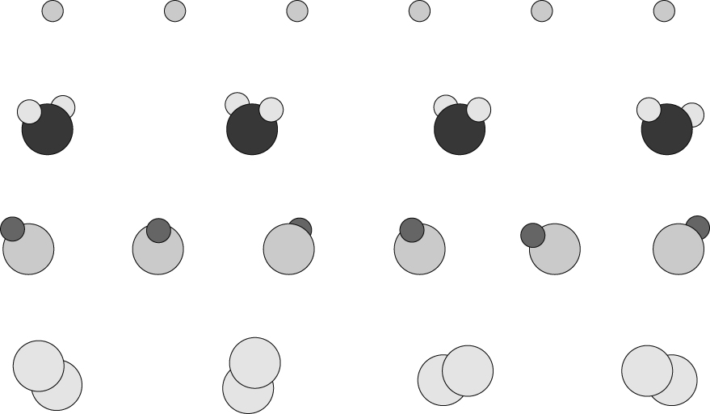
I can...
- recognise the difference between atoms and molecules
- identify elements, mixtures and compounds from descriptions and particle diagrams.

