Protecting teeth
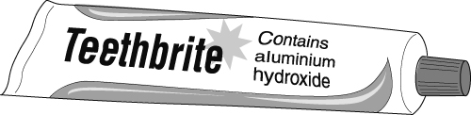
Eating leaves bits of food stuck to your teeth, which bacteria change into acids. The acids can attack your teeth leaving cavities, which a dentist has to fill.
You can protect your teeth by brushing with toothpaste. Brushing gets rid of the bits of food but the toothpaste contains substances that kill the bacteria and react with the acids. One of the substances used to react with acids is aluminium hydroxide. Aluminium hydroxide does not dissolve in water.
- Read the passage above and answer the following questions using one of the answers given.
- Which of the following statements is true?
- Aluminium hydroxide is an alkali but not a base.
- Aluminium hydroxide is an alkali and a base.
- Aluminium hydroxide is a base but not an alkali.
- Aluminium hydroxide is neither a base nor an alkali.
- Which of the following is the correct explanation?
- Aluminium hydroxide dissolves in water and neutralises acids.
- Aluminium hydroxide does not dissolve in water but neutralises acids.
- Aluminium hydroxide does not dissolve in water but neutralises alkalis.
- Aluminium hydroxide dissolves in water and neutralises alkalis.
- What happens to the pH in your mouth when you brush your teeth with toothpaste?
- The pH rises.
- The pH stays constant.
- The pH falls.
- Your mouth doesn’t have pH.
- Design an advert for the toothpaste, showing why it is good for teeth.
- Describe some other examples of reactions between acids and bases in daily life.
I can…
- use the term ‘base’ correctly
- recall a use of neutralisation in everyday life.

