The cosmetics company Splash! is looking to launch a new range of shampoos. A company scientist finds that one shampoo has a pH of 9. She decides that the pH of the shampoo should be about the same as skin which has a pH between 5 and 7. The scientist mixes a sample of the shampoo with water and slowly adds citric acid to it, measuring the pH as she does so.
The graph below shows the results the scientist collected.
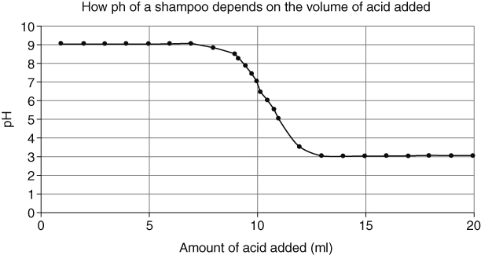
- Describe how the pH changes as the acid is added to the shampoo sample.
- Explain how the scientist can work out the volume of acid needed to neutralise the alkali in the sample of shampoo.
- Explain why it is important for the scientist to work our exactly how much citric acid is needed to get the pH of a batch of shampoo correct.
- Explain why it may be safer to use citric acid to pH balance the shampoo instead of hydrochloric acid.
Splash! need to add potassium nitrate to some of their cosmetics. They decide to make the potassium nitrate themselves.
- Suggest the reactants required to make potassium nitrate.
- Write a word equation for the reaction.
- Describe how the Splash! scientists can make sure that the potassium nitrate is not contaminated by left-over reactants.
I can…
- interpret graphs of pH against volume of reactants in an reaction between acids and alkalis
- use ideas about pH to explain the changes that take place in these reactions.

