Name Class Date
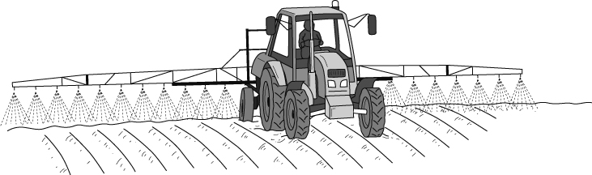
Maisie and Ben went for a walk in the countryside. They saw a farm tractor spraying a ploughed field.
‘What’s the farmer doing?’ Ben asked.
‘I expect he’s putting some alkali on the soil,’ Maisie replied.
‘Oh, I expect that is to react with acid in the soil,’ Ben said.
‘Yes,’ Maisie agreed. ‘The crops won’t grow in acid.’
Answer the following questions.
- a Put a circle around the most likely pH of the field that Maisie and Ben saw before it was sprayed.
1 5 7 9 14
b What should be the pH of the soil after the farmer has sprayed it ?
- Write the name of the reaction that Maisie and Ben described.

The farmer may have been spraying calcium hydroxide solution on the soil. A word equation for the change could be
nitric acid + calcium hydroxide → calcium nitrate + water
- Underline the reactants and circle the products in the word equation.
- Complete the following sentence:
The word equation shows a chemical change because are formed.
I can…
- recall the name of the reaction between acids and alkalis
- explain why it is a chemical change
- identify the reactants and products in a word equation
- recall that reactions between acids and alkalis are used to control the pH of soils.

