
Name Class Date
- Universal indicator can tell us how acidic or alkaline a substance is.
Colour in the chart.
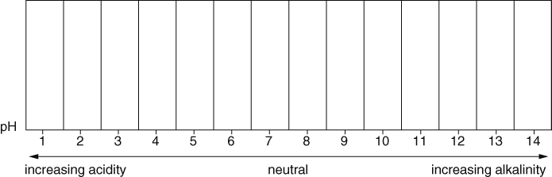
- What is it? Acid, alkali or neutral?
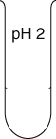  Substance A  It is  Its colour is | 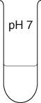  Substance B  It is  Its colour is | 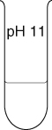  Substance C  It is  Its colour is
- Draw lines to match each substance with its pH and its colour in universal indicator.
Substance |  | pH |  | Colour
stomach acid |  | pH 5–6 |  | green
skin |  | pH 1 |  | yellow
soap |  | pH 10 |  | red
pure water |  | pH 9 |  | green-blue
toothpaste |  | pH 7 |  | dark green
I can…
- describe how universal indicator shows whether a solution is acidic, alkaline or neutral
- describe the main features of the pH scale.

