
Scientists in lots of different areas make use of the pH scale.
- Read the information in the boxes below.
- Pick out the key words from each box. Write a title for each item.
- Use the titles you have written to design a poster about pH. You could add pictures from magazines or from the internet.
- Illustrate each item with the colours of universal indicator for the pH numbers mentioned and state how acidic or alkaline the substances are.
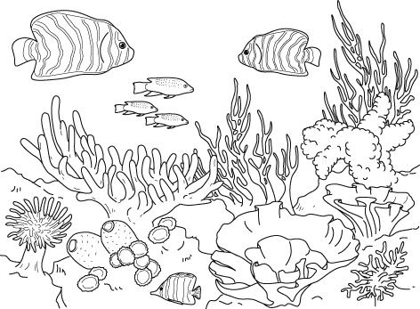  Marine scientists are seeing changes in the pH of seawater as the amount of carbon dioxide in the air increases. This could have a harmful effect on sea creatures such as corals. |  | Hairdressers use many different substances on your hair. Shampoos can have a pH as high as 9. Some makes are ‘pH balanced’ to be the same pH as your skin, about pH 5.5. This is done by adding citric acid with a pH of about 3 to the shampoo. Liquids used to dye hair have a pH of 11.
The drinks that we like have a variety of pH numbers. Mineral water has a pH of about 8. Milk is pH 6.5 but yogurt drinks are around 4.5.
Lemonade is around pH 5. Cola is the lowest of the lot because of the phosphoric acid added to it. It has a pH of 3. It seems we like the sharp taste.
What about beer, the drink for which pH was invented? It has a pH of about 4.
Ecologists have seen a slow improvement in the quality of water in lakes since the 1960s. The dirty coal that used to be used in power stations produced sulfuric acid, which made some lakes as low as pH 2. This killed most fish.  Many streams are back to normal. Chalk streams have a pH of about 7.5 while streams is peaty areas can be about pH 6. |  | A variety of substances are used to clean metals. Dirt and rust can be removed from iron and steel with sulfuric acid at a pH of 1. Aluminium needs cleaning materials that are close to pH 7 while the alloys used for car wheels and exhausts can be cleaned with liquids that have a pH of 12.
Farmers are very interested in the pH of their soils. Wheat and barley prefer a pH just below 7 but potatoes grow well in soils with a pH as low as 5.5. Sugar beet on the other hand, grows in soils at pH 8.
I can…
- use universal indicator and pH numbers to describe solutions as being more or less acidic or alkaline
- I can identify the key points in text and write clear titles to present ideas.

