- Read the following descriptions of substances. Write down what type of hazard, if any, is described in the sentences and write down the letter of the most suitable hazard symbol shown needed for warning about the substance. If there is no risk from the substance write ‘no hazard’.
- Concentrated nitric acid can burn through skin and cause painful sores.
- Ammonium nitrate is used as a fertiliser and is sometimes used in bombs.
- Tartaric acid is used in sauces put on food.
- Dilute nitric acid can cause redness in skin.
- Concentrated ammonium nitrate kills plants and can harm animals in habitats.
- Copper sulfate is used as a weedkiller. It is poisonous if swallowed.
- Alcohol can be lit by a flame.
A   | B   | C  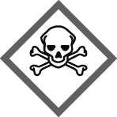 | D   | E  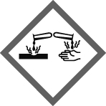 | F  
- A laboratory technician wants to prepare some dilute nitric acid, starting with concentrated nitric acid.
a Describe how the technician can change concentrated nitric acid into dilute nitric acid.
b Describe what safety precautions the technician should take.
c Concentrated nitric acid is usually kept in a locked chemical store room. Dilute nitric acid may be kept in small bottles in a laboratory.
i Explain the different storage arrangements for concentrated and dilute nitric acid.
ii Explain why a risk assessment will suggest that if these arrangements are followed then there is a Low Risk of serious harm to people from both the concentrated nitric acid and the dilute nitric acid.
I can…
- recognise the difference in hazard between substances that are corrosive and irritant
- describe how to reduce the risk of hazards by dilution
- explain the difference between hazard and risk.

