Name Class Date
Acid tastes
Many foods and drinks contain acids. Acids have a sharp or sour taste.
- List 6 drinks, foods and other substances that contain acids.
1 2
3 4
5 6
Hazards
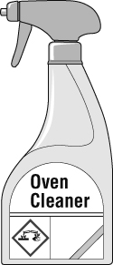
- Look at the diagram showing a bottle of oven cleaner.
Complete the following sentence by circling the correct word or phrase after it.
The label shows that the contents of the bottle are (an acid / corrosive / toxic).
- Draw a line from the hazard symbol to the hazard it is warning of.
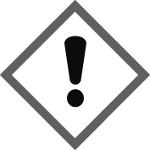 | 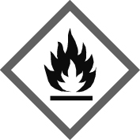 | 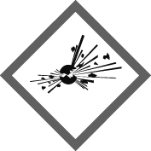 | 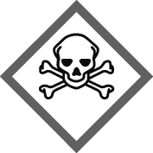
Flammable Toxic Caution (irritant) Explosive
- While doing an experiment in a laboratory, Sam spilled some liquid marked with a corrosive symbol on the bottle. What could Sam do to reduce the risk of harm from the liquid he spilled?

I can…
- recall some substances that contain acids
- recall a reason why hazard symbols are used
- recognise some hazard symbols
- describe what to do to reduce the risk from a hazard.

