
Design a label
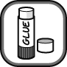
CleanCo have produced a new cleaning material, Pipeclear!, for clearing waste pipes from showers and baths. Pipeclear! contains a substance that can attack hair and fatty deposits that often block pipes. It is poured straight down the pipes to clear them. Unfortunately Pipeclear! will also attack skin and cause painful burns.
CleanCo would like you to design the safety label to go on the Pipeclear! bottle.
Work in groups to design your labels and use coloured pens to make them eye-catching.
The label should show:
- the correct hazard symbol
- explain what the hazard symbol means
- how to safely clear up a spill of Pipeclear!
Explain why there is only a low risk of harm if Pipeclear! is used correctly.
CleanCo also wants to sell a dilute version of Pipeclear! that can be used to clean baths and showers.
Design a label for this product and explain why it is a less serious hazard.
The symbols used for various types of hazard are shown below.
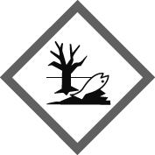 | 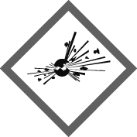
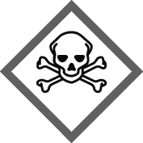 | 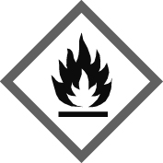
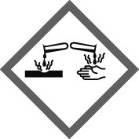 | 
I can…
- tell the difference between substances that are corrosive and irritant
- explain how to reduce the risk of a substance by dilution
- tell the difference between hazard and risk.

