Name Class Date
The diagram shows a section through a simple solar still.
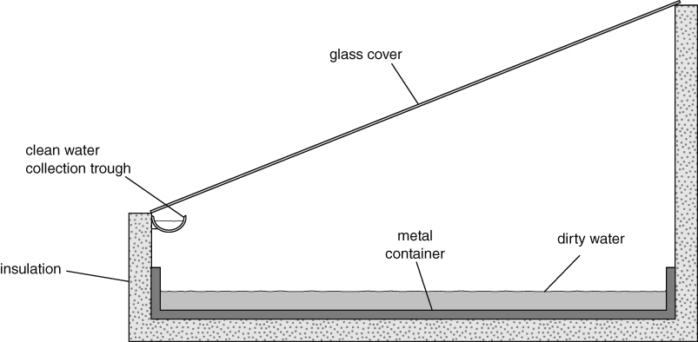
- Describe as fully as you can how the solar still produces clean water from dirty water.

- The process taking place in the still is distillation. Explain what this means.

- Explain why insulating the base of the still increases the amount of clean water collected.

- Describe one other improvement that could be made to the still so that it produced more water. Explain your answer.

I can…
- describe how a solar still works
- explain features of a solar still that affect how it works.

