Name Class Date
The diagram shows a section through a simple solar still.
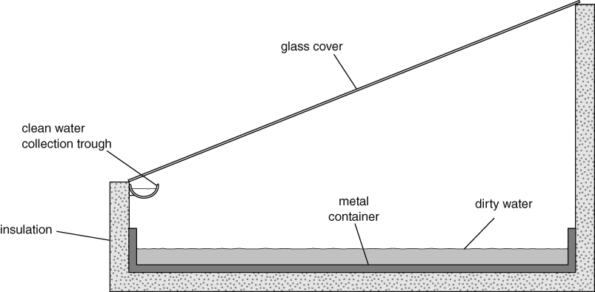
- Complete these sentences using words from the box to explain how the still works.
condenses evaporates heats runs down
- Sunlight passes through the glass cover and the dirty water.
- Water to form water vapour.
- Water vapour on the underside of the cover.
- Water into the collection trough and is piped into a container.
- Which process is taking place inside the solar still? Circle one word.
desalination distillation insulation concentration
- Choose the sentence that best explains why the solar still has an insulated base.
 It helps to produce cleaner water.
 It helps to prevent damage to the metal container.
 It helps the dirty water to stay warmer for longer so more water evaporates.
 It helps the dirty water to stay cooler so that more water vapour condenses.
I can…
- describe how a solar still works
- explain features of a solar still that affect how it works.

