Name Class Date
Drawing A shows the apparatus that Sam used for making a chromatogram. She used six different-coloured inks.
A
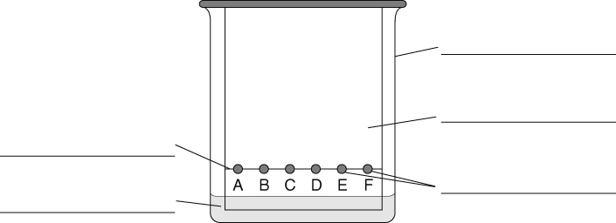
- Label the apparatus using words from the box.
beaker paper pencil line spots of ink water
Drawing B shows what the finished chromatogram looked like.
B
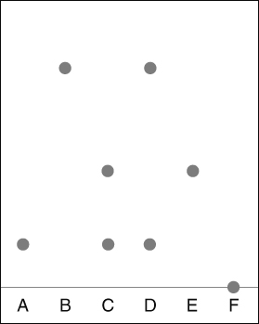
- Three of the inks have only one colour in them.
- Which three are they?
- Explain your answer.

- a Which inks are mixed to make ink C?
b Which inks are mixed to make ink D?
- a Which ink was not soluble in water?
b Explain your answer.
I can…
- Interpret a chromatogram.

