
Name Class Date

I can…
- state examples of where chromatography is used
- explain how chromatography works.
The text below describes two different chromatography methods. Choose one of the methods and use the information given to prepare a poster that describes as clearly as possible in words and diagrams how the method is carried out and what it is used for.
Illustrate your poster using suitable diagrams from below, your own drawings or diagrams from other sources such as the internet. You could add other information from your research.
Gas-liquid chromatography  Gas-liquid chromatography can be used to separate tiny amounts of gases or liquids.  The mixture is put into a special machine.  Gas is added to the mixture to carry it through the machine.  Different substances in the mixture take different times to go through the machine.  The machine detects each substance and produces a graph. Each peak on the graph represents the amount of substance that is detected. | Thin-layer chromatography  A glass or plastic plate is coated with a thin layer of a special powder, which sticks to the plate. Spots of different mixtures are put on the plate and the bottom of the plate is placed in a solvent.  As the solvent spreads up the powder layer, different substances in each mixture are carried at different speeds by the solvent.  After separation, colourless substances may be identified by spraying with locating agents that make them coloured, or by shining ultraviolet light on them to make them glow.

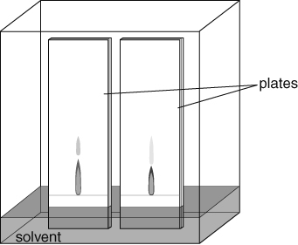 | 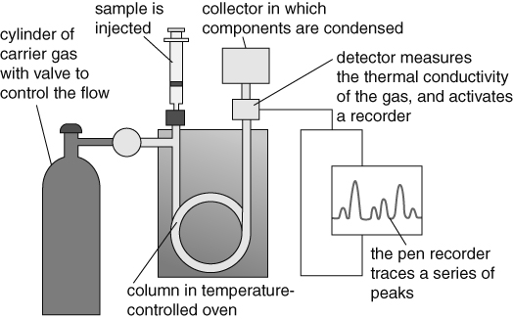
Two chromatograms made with a thin layer of silica spread on glass plates.
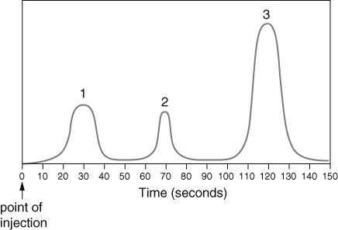 |  | 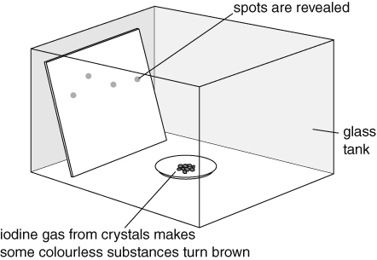
This graph shows that the mixture contained three different substances.

