Name Class Date
When the British ruled India at the beginning of the twentieth century, they passed laws to ban the Indians from making their own salt.
In March 1930, Mahatma Gandhi went to the edge of the sea and picked a pinch of salt from the sand. Thousands of Indian people quickly followed his example and made their own salt by taking a pan of sea water and letting the Sun evaporate the water.
Many people were arrested for doing this but eventually the law was changed again to allow anyone to make their own salt.
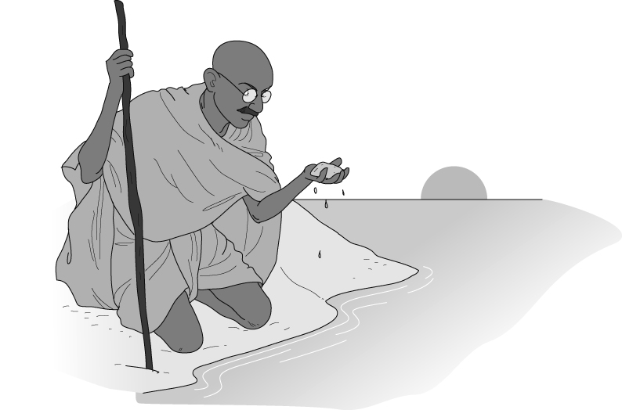
- Why did people make salt from the sea water instead of picking the salt up from the beach as Gandhi had done?
- Would the salt that these people made contain just one substance? Explain your answer.
- In some countries there are salt lakes, which sometimes dry up in the summer. If you collected salt from the lake bed it would be mixed with sand. Design a method to separate the sand from the salt, using normal laboratory apparatus.
- Draw a diagram to illustrate each stage in your method.
- Explain why you need to carry out each step of the process.
- Identify any hazards in your method, and suggest ways to reduce any risks.
I can…
- describe how solutes can be separated from a solution by evaporation
- identify hazards and describe how to reduce the risks from them.

