Name Class Date
Rock salt is a mixture of rock and salt. The instructions below are mixed up.
- Cut out the cards and arrange them in order to describe how to make salt from rock salt.
- Add labels to the diagrams. The words you need are in the box. You will need some words more than once.
beaker bits of rock conical flask evaporating basin funnel heat
pestle pure salt rock salt salty water stirring rod tripod
I can…
- describe how to separate a soluble solid from a solution.

1  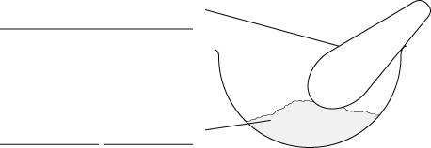 | A Filter the mixture.
 | B Crush up the rock salt using a mortar and pestle.
2  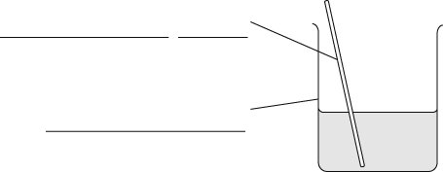 | C The insoluble bits of rock will be trapped in the filter paper. Salty water will go through the filter paper.
 | D You can get the salt from the salty water by evaporating the mixture.
3   | E Put the crushed-up rock salt into a beaker and add water.
 | F This makes sure that there is no salt trapped inside bits of rock.
 | G The salt is soluble and will dissolve. The bits of rock are insoluble and will not dissolve.
4   | H The water evaporates and leaves the salt behind.
 | I The filter paper does not trap the salt because the salt is dissolved in the water.
 | J Stir the mixture to help the salt to dissolve.

