
Name Class Date
- Draw lines to link the labels on the diagram of a Bunsen burner to their functions.
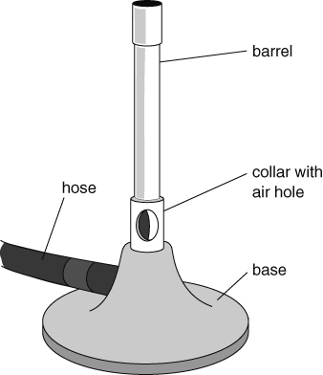 | supplies gas to burner  lifts flame to useful height for heating  keeps the burner stable on a flat surface  controls how much air mixes with gas
- Use the correct colour of pencil to add the flame to each of these Bunsen burner drawings. Remember to draw the correct size of flame, as well as the correct colour.
a flame for heating strongly b flame for gentle heating c safety flame
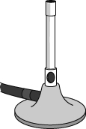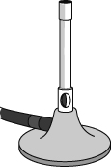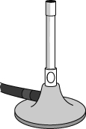
- a Describe one hazard of heating with a Bunsen burner.

b Describe what you could do to reduce the risk of being harmed by that hazard.

I can…
- describe how a Bunsen burner is used
- identify hazards and describe how to reduce the risks from them.

