
Name Class Date
Like most solids, gases also dissolve in water. Fish and other animals and microorganisms that live in the water need oxygen, and they use some of the dissolved oxygen in the water.  The table shows the solubility of oxygen in fresh water and in sea water at different temperatures.  The units are milligrams of oxygen per 1000 cm³ of water.  (1 mg is 1/1000 gram)
  Temperature (°C) | Solubility of oxygen (mg/100 cm³)
  Temperature (°C) | Fresh water | Sea water
  0 | 14.6 | 11.5
  10 | 11.3 | 9.0
  20 | 9.1 | 7.4
  30 | 7.5 | 6.2
  40 | 6.4 | 5.4
  50 | 5.5 | 4.6
  60 | 4.7 | 4.0
- Plot a line graph to show the solubility of oxygen at different temperatures. Put temperature on the horizontal axis and solubility on the vertical axis. Plot the lines for fresh water and salt water on the same axes.
Use your graph to help you to answer these questions.
- a What happens to the solubility of oxygen as the temperature increases?
b How does this compare with the change in solubility of most solids as the temperature increases?
- a Is oxygen more soluble in fresh water or in sea water?
b Which changes most as you increase the temperature – the solubility in fresh water or in sea water? Explain your answer.
- a What is the solubility of oxygen in fresh water at a temperature of 5 °C?
b How hot would the fresh water need to be for oxygen to be only half as soluble as it is
at 5 °C?
Power stations use steam to turn generators to produce electricity. The steam has to be cooled down again. One way of doing this is to use water from a nearby river to cool the steam. The water could be put back into the river afterwards, but it would be a lot warmer than it was before. Instead of doing this, power stations use cooling towers, where the water warmed by the steam is cooled as it falls down the tower.  - If warm water from power stations was put back into rivers, how would this affect fish living in the river?  - Nuclear power stations are often built on the coast. They use sea water for cooling steam, and put the warm water back into the sea. Suggest why this is not as harmful for sea fish as it would be for fish living in rivers. (Hint: there are two reasons.) | 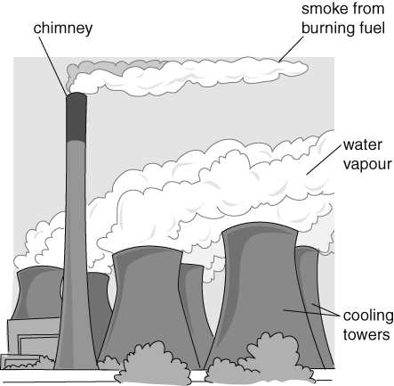
I can…
- describe the effects of different variables on solubility
- apply information about solubility to different contexts
- draw and interpret a line graph.

