
Name Class Date
The table shows how well two substances (potassium nitrate and potassium chloride) dissolve in water at different temperatures. The ‘solubility’ is the number of grams that dissolve in 100 cm³ of water.
Temperature (°C) | Solubility of potassium nitrate | Solubility of potassium chloride
10 | 20 | 32
20 | 30 | 35
30 | 44 | 36
40 | 60 | 38
50 | 78 | 40
60 | 100 | 42

- Draw a line graph to show this information. Use axes like those shown on the right.  - Choose a different colour for each solid, and show these in a key.  - Plot the points on the graph, and join the dots with straight lines.  - Use your graph or the table to help you answer these questions.  a How does the solubility of the substances change as the temperature changes?  b Which substance is the most soluble at 10 °C?  c Which substance is the most soluble at 40 °C?  d This table shows how hot 100 cm³ of water would have to be to dissolve certain amounts of potassium nitrate.  Copy this table, and use your graph to help you to fill in the gaps. | 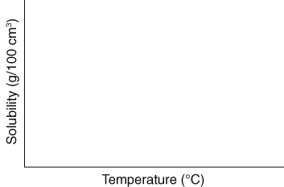
  Mass of chemical (g) | Temperature  of water (°C)
  20 | 10
  25
  30 | 20
  35
  40
  45
  50
  55
  60 | 40
I can…
- draw and interpret a line graph.

