Name Class Date
- A mixture of flour shaken with water is a suspension. Which two statements are true about this mixture? Tick two boxes.
 The flour dissolves in the water.
 The flour is a solid and the water is a liquid.
 The flour will settle to the bottom of the container if the mixture is left to stand.
 The flour will stay dispersed in the water and will not settle out if left to stand.
- The pictures show some examples of colloids. For each colloid, identify the state of each substance in it. Choose words from the box.
 | solid liquid gas
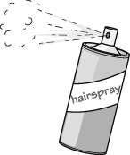  colloid of hairspray and air  state of hairspray: .  state of air: . |  | 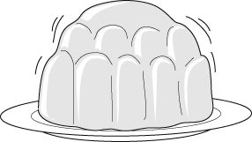  colloid of gelatine and water  state of gelatine: .  state of water: .
- Here are some objects made of colloids and some useful properties. Draw a line from each object to the useful property of the colloid from which it is made.
Object |  | Useful property
Styrofoam™ cup |  | The water helps it to spread more thinly.
hairspray |  | The water is absorbed and locked away.
gel in a disposable nappy |  | The air stops heat passing quickly through.
hand cream (skin softener in water) |  | The air spreads the liquid droplets so you don’t get too much in one place.
I can…
- identify different kinds of mixture
- identify the states of matter for substances in a mixture.

