Imagine you are going to have a debate about the following:
You can be fined up to £50,000 for fly-tipping and/or up to 5 years in prison.
Do you think this is reasonable?
In a debate, you need to speak about what you think and try to convince others that you are right. So you need to prepare a good speech. Other people will speak against you, arguing for a different point of view. So you need to think about what they might say.
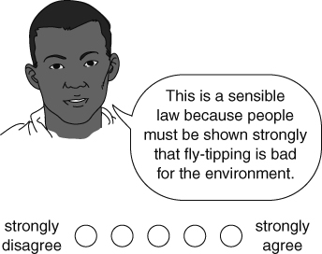 | 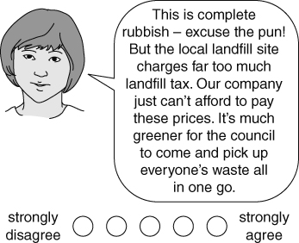
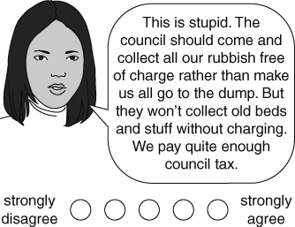 | 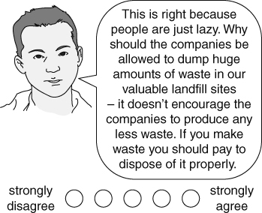
Answer on the back of this sheet
What do you think of each person’s views? Use the circles to show how strongly you agree or disagree with each person.
What do you think of the law?
Write a bullet point list of things that you would mention in a debate to argue your scientific ideas.
What other things would you like to find out? How will you find them out?
I can…
- develop clear points in order to present ideas and opinions.

