Name Class Date
Your teacher may show you some or all of these experiments.
Explain how air pressure keeps the water in the glass. | 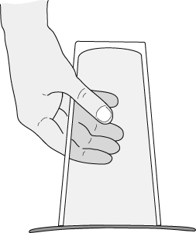
Describe what happens in the experiment shown opposite.  Explain how air pressure makes the egg go into flask. | 