Name Class Date
In Italy, 350 years ago, some scientists set about trying to show that a vacuum (nothingness) could exist. They had a long tube like this:  When they opened the tap at the bottom, some of the water fell out, but most of it stayed in. There was a gap at the top. No air could get in, so they thought that this was a vacuum (a place with no air or anything else in it).  When they undid the lid, they could hear a hissing sound as air rushed in.  The scientists changed the tube and put a bell in the top. Sound needs a substance to travel through. They thought that if there was no air there, they would not be able to hear the bell. When they had made a gap at the top, they used a magnet to move the bell and make it ring. They heard it ring.  Evangelista Torricelli (1608–1647) thought that their experiment had not been a very good one. Sound can travel through solids, and the bell was hanging on a solid bar that was attached to the glass. They had not proved anything at all! He decided to do some experiments of his own. | 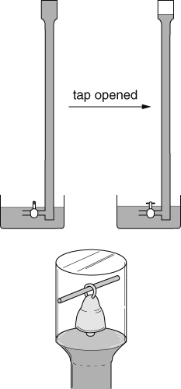
The phrases in italics are observations, hypotheses or predictions.
- Underline all the phrases that are observations in red.
- Underline all the phrases that are hypotheses in blue.
- Underline all the phrases that are predictions in green.
Why did the scientists think they should not be able to hear the bell?

Why did Torricelli think that they had heard the bell?

Why did Torricelli decide to do his own experiments?

I can…
- explain that scientific theories are based on based on observations
- describe what a vacuum is.

