Name Class Date
Two students are each given a plastic drinks bottle with a balloon stretched across the neck as shown opposite.
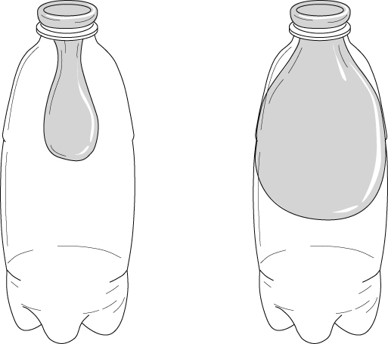
The bottles look identical, but one has a small hole in the bottom. Explain what happens,
in terms of air pressure, when the students try to blow up the balloons.

I can…
- recall some effects of gas pressure
- use particle theory to describe the cause of air pressure.

