Name Class Date
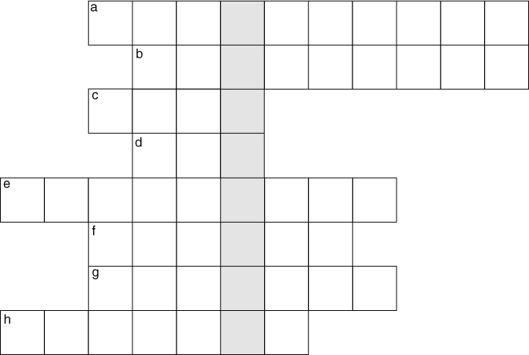
Write your answers to the clues in the grid above.
- Solids, liquids and gases all have different .
- Everything is made of tiny pieces called .
- Particles in a liquid or a gas can around.
- A has particles that are a long way apart.
- Smells spread through the air by .
- If you pump all the air out of a space, you have a .
- Particles in a solid cannot move around, they can only .
- Solids and liquids both have fixed .
Write down the word in the shaded boxes. .
Now write your own clue for this word.

I can…
- use particle theory to explain the properties of solids, liquids and gases.

