Name Class Date
The diagram below shows the air particles inside and outside a car tyre.
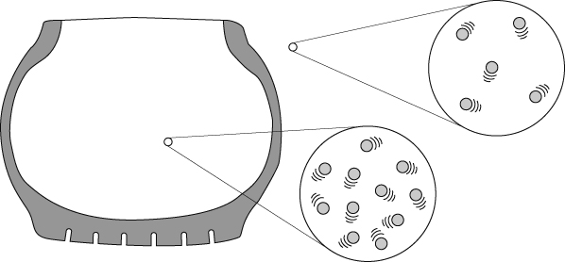
Complete these sentences about air pressure.
The particles of all gases freely in all directions.
Air pressure is caused by the moving gas particles with surfaces.
Inside the tyre there are air particles, in the same volume, than outside the tyre.
Air pressure inside a tyre increases if you put gas particles into the tyre.
The air pressure is higher because more gas are hitting the surface.
The plunger on the syringe on the right has been pushed in half way and the gas pressure inside the syringe has doubled.
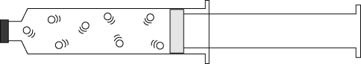 | 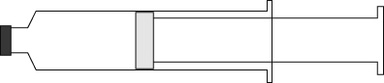
- Complete the diagram on the right showing the gas particles inside that syringe.
- What causes the air pressure inside the syringe on the right to increase?

I can…
- recall some effects of gas pressure
- use particle theory to describe the cause of air pressure.

