Name Class Date
The diagrams on the right show the particles inside a car tyre at low pressure.  Complete the second drawing to show the particles in a tyre that has been pumped up to a higher pressure.  Use some of the words in the box below to complete the sentences below about air pressure.  - Gas particles freely in all directions.  - Air pressure is caused by the gas particles  surfaces.  - You can increase air pressure by putting  air into a tyre. |  | 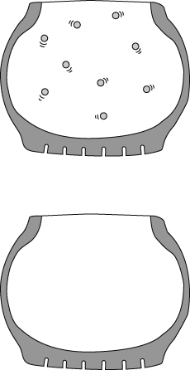
  hitting less move more still
When we turn on the vacuum pump the plastic bottle collapses.
Tick (✓) the correct phrase to complete these sentences.
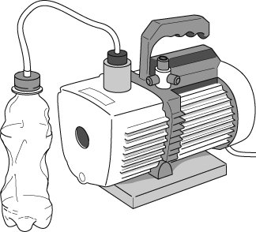 | A vacuum is an space which contains  … only air.   … no particles.   … only a liquid.   … no solids or liquids.   The bottle collapses because  … the particles on the inside stop moving.   … the particles on the outside move faster.   … the air pressure on the outside pushes it in.   … the air pressure on the outside has increased. 
I can…
- recall some effects of gas pressure
- use particle theory to describe the cause of air pressure.

