
I can…

- use particle theory to explain diffusion in liquids and in gases.
The drawings below show the steps that occur during diffusion of gases and liquids. There are three drawings about gases and five drawings about liquids. They are all jumbled up.
Cut out the drawings and put them in the correct order. Glue the gases and the liquids on separate sheets of paper.

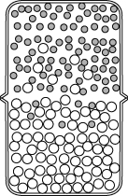 | 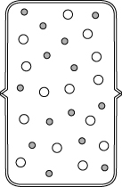
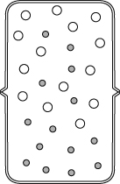 | 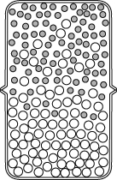
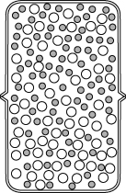 | 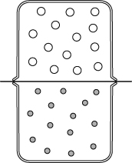
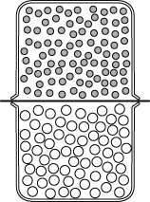 | 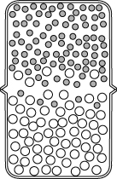
If you are not using worksheet 7Gd-5 then write a sentence or two, on each piece of paper, to explain what is happening at each stage of the mixing process.

