Name Class Date
Someone has dumped rubbish at a pond. Liquid soap has leaked from the rubbish into the pond and the rubbish is just starting to smell. It is a hot, windless day. | 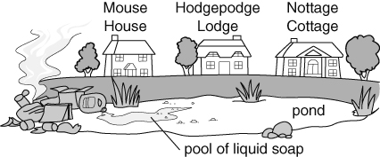
- The smell and the liquid soap both spread. What is this spreading caused by?
Tick one box.
 true  dissolving
 diffusion  distraction
 dispersion  wind
- Shade the drawing to show how far the smell and the soap will have spread in a
few hours.
- Mrs Gupta is the first to complain to the council about the smell. Which house does she
live in?

- Explain your answer to part c.

- The people in which house will be next to smell the rubbish?

The man from the local environmental agency has phoned Mrs Gupta.  - What is a prediction? Tick one box.   saying what you think will happen   saying what has happened   pronouncing your words correctly   explaining what has happened  - A scientific prediction is one that can be tested.  Which person makes a scientific prediction? | 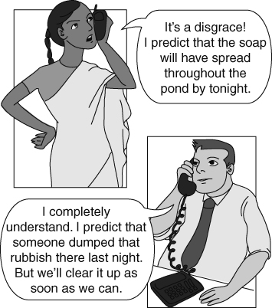
I can…
- use particle theory to explain diffusion in liquids and in gases
- make a prediction using scientific ideas.

