You are going to observe what happens when two different gases diffuse through the air. Ammonia solution gives off ammonia gas and hydrochloric acid gives off hydrogen chloride gas.
Prediction
Copy the diagram.
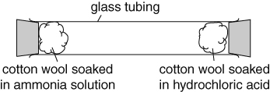
How do you think the particles will move? Discuss your ideas with a partner and draw a diagram to show what you think will happen.
Particles of hydrogen chloride are about twice as heavy as particles of ammonia. When hydrogen chloride and ammonia gases meet, a white smoke appears. Where in the tube do you think the white smoke will appear? Put a cross on your diagram to show your prediction.
Explain your prediction in terms of the movement of particles.
Recording your results
a When your teacher puts the cotton wool in the tube, start timing. Look carefully to see when the white smoke appears. As soon as you see the smoke, stop timing.
b Measure how far each gas has travelled.
Considering your results/conclusions
Which gas moved faster? Did this agree with your prediction?
a Do you think your original explanation was correct, or have you changed your ideas?
b If your ideas have changed, explain how and why.
Use this formula to calculate the speed of each gas:
speed = $\frac{\text{distance}}{\text{time}}$
Evaluation  Read Joe’s conclusion on the right. Do your results support this conclusion?  Have you got enough results to be sure?  If this pattern worked, what result would you expect if you did an experiment where one gas was three times as heavy as the other? | 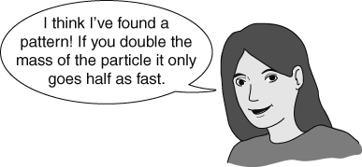
I can…
- make a prediction using scientific ideas
- make calculations using a formula
- use particle theory to explain how particles move, including the effect of mass.

