Name Class Date
1 Robert was asked to set up an experiment to investigate diffusion  He set up three test tubes containing blue crystals of copper(II) sulfate, covered with water. Each test tube was kept at a different temperature.  After some time he observed that the blue colour had spread as shown in the diagram opposite. | 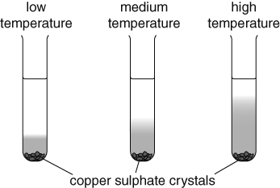
a What happens during diffusion?

b Which part of particle theory explains diffusion?

c What hypothesis is Robert trying to investigate.

d What conclusion could Robert draw from the results shown in the diagram?

e If diffusion occurs in solids, will it be faster or slower than in liquids? Explain your answer.

2 Imagine that you are a particle of a perfume. Describe what happens to you when the bottle is opened and eventually someone smells you on the other side of the room. Your description should include, how you move, what other particles you might meet and where you go. | 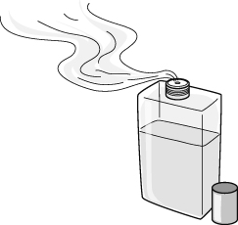
I can…
- use particle theory to explain diffusion in liquids and in gases
- think of a model to explain an observation.

