Aim
Does diffusion depend on temperature?
Hypothesis
The speed at which a coloured substance diffuses through a liquid depends on the temperature.
Prediction
a How do you think the temperature will affect the speed of diffusion?
b Explain your ideas using particle theory if you can.
Planning
How will you measure the speed of diffusion? How many different temperatures will you try?
Will you measure the temperature or just describe it (e.g. cold, warm, hot)?
Apparatus  - clock, watch or stop clock  - ruler  - some glasses or clear beakers  - something that dissolves in water with a strong colour  (e.g. a spoonful of Marmite® or meat or yeast extract, a weighted teabag, some food colouring with a small dropper) |  If you are doing this experiment at home, check your plan with adults. Do not use boiling water.
Method
- Collect your glasses. Fill them with water at the correct temperatures for your plan.
- Leave the water to stand for a few minutes so that it has stopped moving.
- Carefully put your coloured substance at the bottom of the glass. Do not stir the water.
- Leave the glasses of water absolutely still. Look at the glasses again after 2 minutes. How far has the colour spread through the water? Measure the distance in cm with a ruler.
- Take measurements every 2 minutes. Stop when the colour has spread all the way through the water, or after about 20 minutes.
Considering your results/conclusion  Plot a line graph of the distance travelled by the colour against the time. Use axes like those on the right:  Use a different colour for each temperature.  Use your graph to work out at which temperature the colour diffused the fastest.  Describe how changing the temperature affects the speed of diffusion.  Did this result agree with your prediction? | 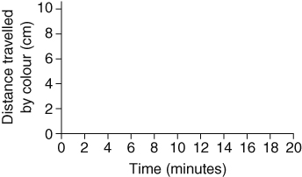
I can…
- make a prediction using scientific ideas ● select suitable apparatus
- use particle theory to explain diffusion ● present data as a line graph.

