Name Class Date
Brownian motion trace
The diagram below shows the magnified Brownian motion trace for one speck of smoke, suspended in air. The trace was produced in 10 seconds and has been magnified 100 times.
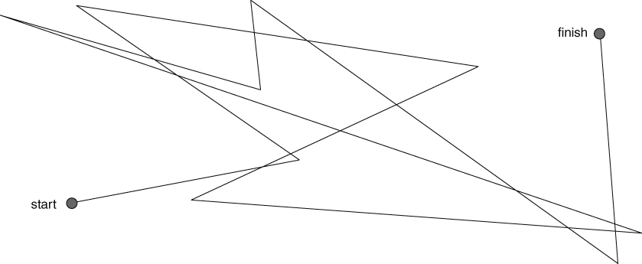
Brownian motion trace (× 100 magnification)
Suggest one word that describes the motion of the speck of dust.
You will need to use a ruler with a millimetre (mm) scale, or the scale at the bottom of this sheet, to answer this questions.
- What is the straight line distance between the start and the finish in the diagram?
- Measure the total distance travelled by the speck of soot from the start to the finish of all its movements.
The diagram has been magnified 100 times.
What is the real distance travelled in questions 2a and 2b?
The mean speed of a particle can be calculated by the formula below.
mean speed = $\frac{\text{distance}}{\text{time}}$
where distance is in metres (m); time is in seconds (s) and speed is in metres per
second (m/s).
Calculate the mean speed of the particle using the distance calculated in question 3.
Brownian motion was finally explained by using the idea that air, like all matter is made up of particles.
- Why can we not see the particle in air?
- How do the particles of air produce Brownian motion?
I can…
- use particle theory to explain how Brownian motion occurs
- carry out simple measurements and calculations on scientific data.

