Name Class Date
Brownian motion …
- In 1827, Robert Brown observed that pollen grains in water moved about jerkily.
- Brown thought that the movements might be due to the pollen grains being alive.
- He thought that ‘dead’ particles would not show the same jerky motion.
- A repeat experiment was set up using 100 year old pollen grains, which could not be alive.
- However the ‘dead’ pollen showed the same jerky motion as fresh pollen.
- Other scientists set up experiments using non living dust instead of pollen.
- Again the dust showed the same jerky motion as fresh pollen.
- Albert Einstein thought the jerky motion was caused tiny water particles hitting the pollen.
- In 1905 Einstein used his idea to estimate of how far a pollen grain would move.
- In 1908 Jean Perrin carried out experiments that showed Einstein’s ideas were correct.
- Many pieces of evidence supported the idea that all matter was made up of moving particles.
Scientific methods …
Which stage of this scientific method does each of the statements above match? Write the letters A to K next to the stage of this scientific method in the flow diagram below.
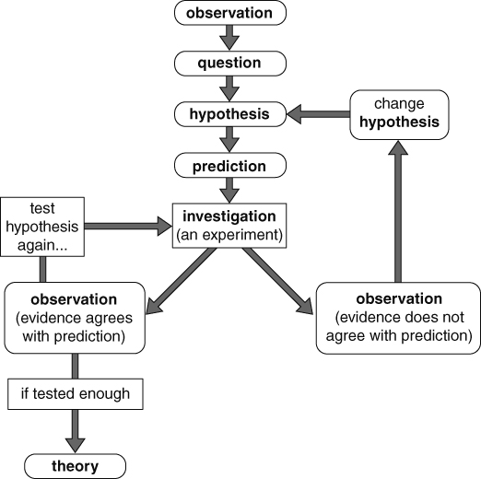
Another scientist tried to repeat Robert Brown’s experiments using soot. Suggest a hypothesis and prediction for this experiment.

I can…
- suggest suitable hypothesis and predictions for an investigation
- identify different stages of the scientific method.

