Name Class Date
The diagram and sentences below describe Brownian motion and how it can be explained.
Complete the sentences below using words from the box.
change directions colliding microscope many
moving particle push
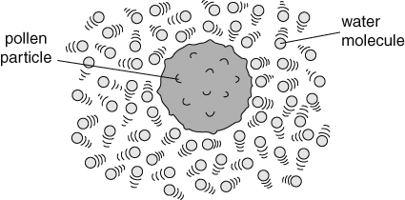
Brownian motion was first seen by looking at pollen grains in water with a .
The pollen was seen to be jerkily in different directions.
This can be explained by the theory of matter.
Water, like all matter, is made up of tiny particles that are moving about in all .
The water particles therefore are with the pollen grains.
This will the pollen grain.
If water particles hit one side of a pollen grain then, they push the pollen in that direction.
Since the particles move at random the direction the pollen is pushed in will
all the time.
I can…
- use particle theory to explain Brownian motion.

