
Cut out the boxes below and arrange them in three groups to show the correct description of the particles in solids, liquids and gases.
I can…
- describe the three states of matter in terms of their properties and identify a solid, liquid or gas from the arrangement of particles.

Gas | not easily squashed | 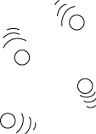 | easily squashed
not easily squashed | particles close together | particles far apart | Liquid
particles move freely in all directions | strong forces of attraction between particles | volume and shape | 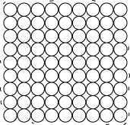
do not change weak forces of attraction between particles | particles quite close together | Solid | fixed volume,  shape can change
particles can move over each other | 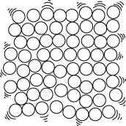 | no fixed volume,  no fixed shape | particles vibrate in fixed positions

