Name Class Date
Waste comes in different states that have to handled in different ways.  Solid waste, like scrap metal, is often transported in open ‘skips’ but liquid waste, like sewage, is carried in a tanker.  Gases always have to be kept in sealed containers. For storage and transport the gases are often pressurised so that a large volume of gas can be squeezed into a small cylinder.  When solid waste has been stored for a long time it can rot and form liquids and gases. This can be a problem if these escape into the environment. | 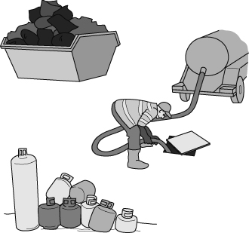
a Draw a diagram in the box below to represent the particles in a solid metal. Then tick the correct statements which describe the movement and spacing of the particles in the metal.
- Close together and moving freely.
- Far apart and fixed in position.
- Close together and fixed in position.
- Far apart and moving freely.
b Use your ideas about metal particles to explain why metal waste can be transported in an open skip.

Use your ideas about liquid particles to explain why liquids can be easily pumped down pipes but cannot be transported in an open truck.

Circle the correct word or words to complete these sentences about gases.
- The particles in gases are (close together / far apart).
- The particles in gases can move (over each other / freely in all directions).
- The forces between the particles of gas are (strong / weak).
Use your ideas about gas particles to explain how gases can be compressed into a cylinder.

Explain why the formation of liquids and gases in a landfill site can cause environmental problems.

I can…
- use particle theory to explain the properties of matter.

