The particle model of matter
The particle model theory can be used to explain the difference between the three states of matter. This theory was formed over a number of years by the work of many scientists. Starting with a question like, ‘Why do liquids flow while solids keep their shape?’, the scientists have thought up hypotheses which they have investigated by making predictions and tested by observing experiments.
Write one sentence which states how the particle model of matter describes the difference between solids, liquids and gases.
What is the difference between a hypothesis, a prediction and a theory?
Write down another scientific question about matter, like the one in the above passage.
For each of the following examples explain the observation by using the particle model of matter.
a  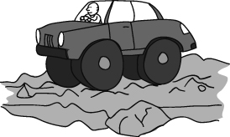  Car tyres used to be made of solid rubber. Modern tyres are filled with gas. They produce a much more comfortable ride than the solid tyres. | b  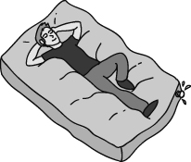  A water bed is filled with water. Some people find that a water bed is more comfortable than an ordinary mattress.
Suggest a hypothesis and a prediction that could be being tested in the experiment being shown opposite? | 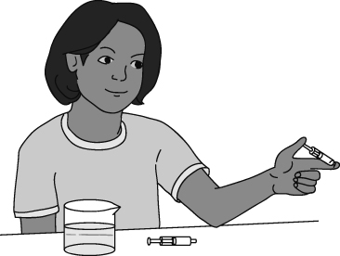
I can…
- describe the particle theory of matter
- identify scientific questions
- tell the difference between a hypothesis, a prediction and a theory.

