Name Class Date
Write a meaning for the following terms.
- Observation
- Hypothesis
- Theory
- Evidence .
- The scientific method
Complete the table below about the particle theory of matter and the properties of the three states of matter.
State | Solid |  | Gas
Drawing of particles | 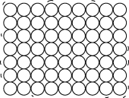 | 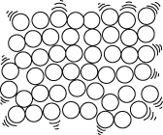
Spaces between the particles | Very small spaces between the particles
Freedom of movement of particles |  | Particles can move around each other
About shape |  |  | Changes shape to fill container
About volume | Have a fixed volume |  | Spread out, have no fixed volume
I can…
- state the meaning of terms associated with the scientific method
- describe how the particles are arranged in solids, liquids and gases.

