To reduce the amount of rubbish that goes to landfill sites we need to study the types of rubbish we produce. The percentage of different types of waste thrown away in the UK is shown below. The same data is shown in three different ways.
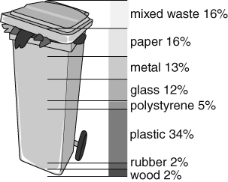 | 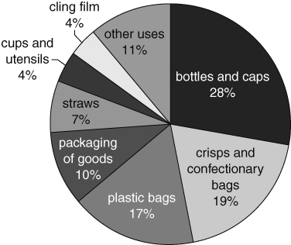 | 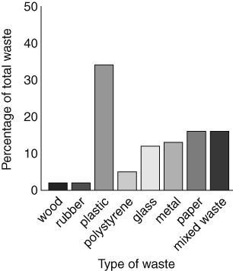
These questions are about using the above information.
What is most of our waste made up of?
On average each person in the UK produces 500 kg of waste a year. What mass of waste glass is produced by each person in an average year?
The contents of our bins would have been very different 100 years ago. Which of the types of waste described above would hardly be present 100 years ago? Explain your answer.
These questions are about ways of displaying information.
- a Draw up a table, with suitable headings, to show the same data.
b List the different ways that the data in the table could be ordered.
c Explain the order you used for the table in your answer to question 4a.
- There are four ways of displaying the information: pie chart; bar chart, graphic and table.
Which of the methods fits the following descriptions. Give a reason for your choice in case.
- The simplest display to get information from.
- The best choice for use in a poster on ‘Waste’.
These questions are about the types of waste.
- Used cooking oil is now usually recycled rather than sent to a waste dump.
a Describe in terms of particles how cooking oil can flow but is not easily compressed.
b Explain why cooking oil is easier to transfer to tankers, but more difficult to store, than the waste materials in the above data.
I can…
- understand and use different ways of presenting data
- use data in a scientific context.

